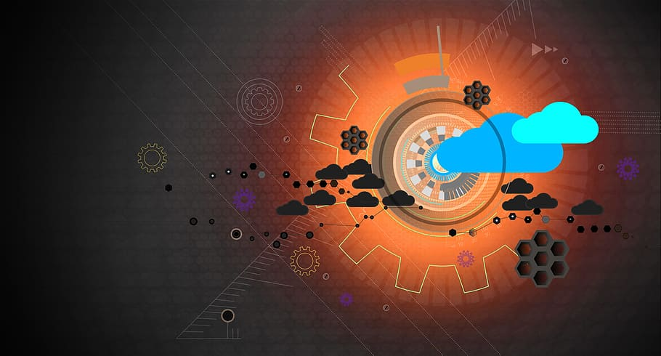

Intro to Computing

CA: SOFTWARE DEVELOPMENT

STUDENT: DIANA CABEZAS. STUDENT #: 2023073. DATE: 21.05.2023

Table of Contents

Introduction: 3

1.) Two high-level flowcharts of the program 3

a. Manager Flowchart: 3

b. Staff Flowchart: 3

c. Manager mock-ups: 4

d. Staff mock-ups: 4

e. A brief explanation of how the data is processed. 4

f. A brief explanation of any testing to be performed. 5

g. e. A brief explanation of how this software will be distributed. 6

2.) Report: 6

a. How the data is securely transmitted. 6

b. A discussion of some of the legal, ethical and privacy issues that may arise. 6

References: 7

Video link:

<https://youtu.be/vxW8TBOdumg>

# Introduction:

A new, up-and-coming restaurant has recently seen a massive growth in popularity and as a result would like to hire more staff. However, they have no system to help schedule all their staff and desperately need to get one! My mission is to investigate the possibility of developing a new scheduling program.

This program will allow employees to request shifts and the manager to then generate a schedule that tries to fit these requests.

# Two high-level flowcharts of the program

## Manager Flowchart:

## Staff Flowchart:

## Manager mock-ups:

## Staff mock-ups:

## A brief explanation of how the data is processed.

With this application I have decided that the way we will process data will be trough Electronic Data Processing (EDP). This allows us with modern technologies to use data processing software and programs.

Using EDP Framework we will obtain:

* Effective Version control
* Smooth Collaboration
* Better Timelines
* Security and control
* Cost-effective
* Better management

## A brief explanation of any testing to be performed.

This error message was obtained with the shift cancellation test outside the allowed time.

This error message was obtained with the Log in when these are incorrect. Also, this log tells the user that has 3 attempts.

## e. A brief explanation of how this software will be distributed.

This software will be distributed using Digital distribution this delivers content such as books, movies and TV programs, music, software, and video games via media-specific channels, platforms, and devices. The content can either be downloaded or streamed which will make it easier for the user to get it.

# Report:

## How the data is securely transmitted.

Data Security Management maintains data integrity along with preventing data from unauthorized access.

Encryption involves translating plain text into cipher text using encryption key. This Cipher text is converted into plain text at receiver’s end using decryption key. Encryption allows any message to be transmitted without the fear of interception. Encryption is of two types:

* Private Key Encryption
* Public Key Encryption

In this case will be using public key cryptography considering this remains the most secure protocol (over private key cryptography) because users never need to transmit or reveal their private keys to anyone, which lessens the chances of cyber criminals discovering an individual’s secret key during the transmission.

## A discussion of some of the legal, ethical and privacy issues that may arise.

**1. Data mining for identity theft**. Scammers do not need a great deal of information to steal someone's identity. They can start with publicly available information on social media to help target victims. For example, scammers can gather usernames, addresses, email addresses and phone numbers to target users with phishing scams. If the software fails to protect this personal data due to security vulnerabilities, hackers who gain access to this information can use it to commit fraud and other crimes.

**2. Internal threats.** Most of the time we worry about external threats, but sometimes certain security policy vulnerabilities are due to human error. We have to keep in mind that people might not consider the security implications of their actions, so both privacy and data access policies are important to guiding and informing people how to maintain security while handling sensitive data.

**3. Inappropriate use of data.** This type of problem could come from many sources the employees, manager and especially the party that has access to all the vulnerable information.

**4. Copyright infringement.** This occurs when the violating party exercises any of the creator's exclusive rights to the work without permission as small company you could be expose to it if we talk about costs.

**5. Data loss**. Is the intentional or unintentional destruction of information, caused by people and or processes from within or outside of an organization. That’s why we need to be careful with what kind of permissions we are going to give to our users. We don’t want to give to many privileges because this will lead us to data loss or data exposure.

# References:

www.legalzoom.com. (2023). *Understanding digital distribution rights*. [online] Available at: https://www.legalzoom.com/articles/understanding-digital-distribution-rights#:~:text=Digital%20distribution%20is%20the%20delivery [Accessed 21 May 2023].

Wikipedia. (2021). *List of mobile app distribution platforms*. [online] Available at: <https://en.wikipedia.org/wiki/List_of_mobile_app_distribution_platforms>.

‌peda.net. (n.d.). *DATA PROCESSING IN COMPUTER*. [online] Available at: <https://peda.net/kenya/ass/subjects2/computer-studies/form-3/data-processing>.

www.bartleby.com. (n.d.). *Ethical and Legal Issues | bartleby*. [online] Available at: <https://www.bartleby.com/subject/engineering/computer-science/concepts/ethical-and-legal-issues>.

Lee, W., Zankl, W. and Chang, H. (2018). *An Ethical Approach to Data Privacy Protection*. [online] www.isaca.org. Available at: <https://www.isaca.org/resources/isaca-journal/issues/2016/volume-6/an-ethical-approach-to-data-privacy-protection>.